Experiment:10

Title :

Write a code in JAVA for a simple Word Count application that counts the number of
occurrences of each word in a given input set using the Hadoop Map-Reduce framework on local-standalone set-up.

Aim :

Count the number of occurences using Hadoop Map Reduce

Prerequisites:

JDK and Hadoop installation

Objectives :

counts the number of occurrences of each word in a given input set

Theory:

In Hadoop, MapReduce is a computation that decomposes large manipulation jobs into individual tasks that can be executed in parallel across a cluster of servers. The results of tasks can be joined together to compute final results.
MapReduce consists of 2 steps:
- Map Function – It takes a set of data and converts it into another set of data, where individual elements are broken down into tuples (Key-Value pair).
Example – (Map function in Word Count)

Input | Set of data | Bus, Car, bus, car, train, car, bus, car, train, bus, TRAIN,BUS, buS, caR, CAR, car, BUS, TRAIN
Output | Convert into another set of data  (Key,Value) | (Bus,1), (Car,1), (bus,1), (car,1), (train,1),  (car,1), (bus,1), (car,1), (train,1), (bus,1),  (TRAIN,1),(BUS,1), (buS,1), (caR,1), (CAR,1),  (car,1), (BUS,1), (TRAIN,1)

- Reduce Function – Takes the output from Map as an input and combines those data tuples into a smaller set of tuples.
Example – (Reduce function in Word Count)

Input  (output of Map function) | Set of Tuples | (Bus,1), (Car,1), (bus,1), (car,1), (train,1),  (car,1), (bus,1), (car,1), (train,1), (bus,1),  (TRAIN,1),(BUS,1), (buS,1), (caR,1), (CAR,1),  (car,1), (BUS,1), (TRAIN,1)
Output | Converts into smaller set of tuples | (BUS,7),  (CAR,7),  (TRAIN,4)

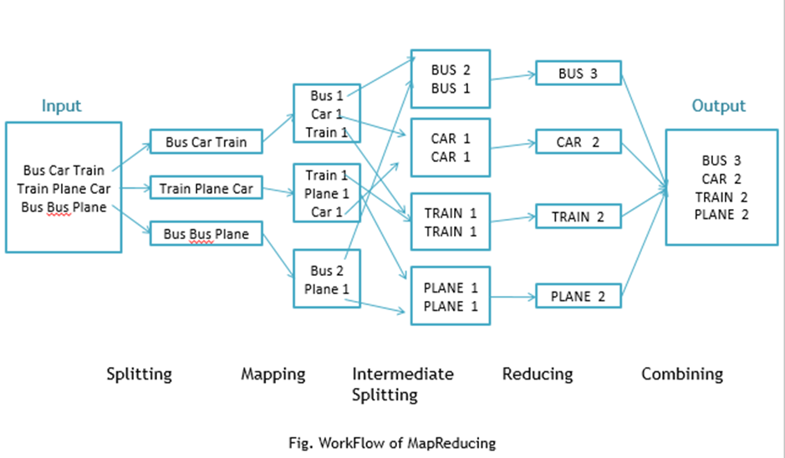

Workflow of MapReduce consists of 5 steps:
- Splitting – The splitting parameter can be anything, e.g. splitting by space, comma, semicolon, or even by a new line (‘\n’).
- Mapping – as explained above.
- Intermediate splitting – the entire process in parallel on different clusters. In order to group them in “Reduce Phase” the similar KEY data should be on the same cluster.
- Reduce – it is nothing but mostly group by phase.
- Combining – The last phase where all the data (individual result set from each cluster) is combined together to form a result.

Steps
- Open Eclipse> File > New > Java Project >( Name it – MRProgramsDemo) > Finish.
- Right Click > New > Package ( Name it - PackageDemo) > Finish.
- Right Click on Package > New > Class (Name it - WordCount).
- Add Following Reference Libraries:
  - Right Click on Project > Build Path> Add External
    - /usr/lib/hadoop-0.20/hadoop-core.jar
    - Usr/lib/hadoop-0.20/lib/Commons-cli-1.2.jar

package PackageDemo;

import java.io.IOException;
import org.apache.hadoop.conf.Configuration;
import org.apache.hadoop.fs.Path;
import org.apache.hadoop.io.IntWritable;
import org.apache.hadoop.io.LongWritable;
import org.apache.hadoop.io.Text;
import org.apache.hadoop.mapreduce.Job;
import org.apache.hadoop.mapreduce.Mapper;
import org.apache.hadoop.mapreduce.Reducer;
import org.apache.hadoop.mapreduce.lib.input.FileInputFormat;
import org.apache.hadoop.mapreduce.lib.output.FileOutputFormat;
import org.apache.hadoop.util.GenericOptionsParser;

public class WordCount {
public static void main(String [] args) throws Exception
{
Configuration c=new Configuration();
String[] files=new GenericOptionsParser(c,args).getRemainingArgs();
Path input=new Path(files[0]);
Path output=new Path(files[1]);
Job j=new Job(c,"wordcount");
j.setJarByClass(WordCount.class);
j.setMapperClass(MapForWordCount.class);
j.setReducerClass(ReduceForWordCount.class);
j.setOutputKeyClass(Text.class);
j.setOutputValueClass(IntWritable.class);
FileInputFormat.addInputPath(j, input);
FileOutputFormat.setOutputPath(j, output);
System.exit(j.waitForCompletion(true)?0:1);
}
public static class MapForWordCount extends Mapper<LongWritable, Text, Text, IntWritable>{
public void map(LongWritable key, Text value, Context con) throws IOException, InterruptedException
{
String line = value.toString();
String[] words=line.split(",");
for(String word: words )
{
Text outputKey = new Text(word.toUpperCase().trim());
IntWritable outputValue = new IntWritable(1);
con.write(outputKey, outputValue);
}

}
}

public static class ReduceForWordCount extends Reducer<Text, IntWritable, Text, IntWritable>
{
public void reduce(Text word, Iterable<IntWritable> values, Context con) throws IOException, InterruptedException
{
int sum = 0;
for(IntWritable value : values)
{
sum += value.get();
}
con.write(word, new IntWritable(sum));
}

}

}

The above program consists of three classes:
- Driver class (Public, void, static, or main; this is the entry point).
- The Map class which extends the public class Mapper<KEYIN,VALUEIN,KEYOUT,VALUEOUT> and implements the Map function.
- The Reduce class which extends the public class Reducer<KEYIN,VALUEIN,KEYOUT,VALUEOUT> and implements the Reduce function.
6. Make a jar file
Right Click on Project> Export> Select export destination as Jar File > next> Finish.
7. Take a text file and move it into HDFS format:
To move this into Hadoop directly, open the terminal and enter the following commands:

[training@localhost ~]$ hadoop fs -put wordcountFile wordCountFile

8. Run the jar file:
(Hadoop jar jarfilename.jar packageName.ClassName PathToInputTextFile PathToOutputDirectry)
[training@localhost ~]$ hadoop jar MRProgramsDemo.jar PackageDemo.WordCount wordCountFile MRDir1

9. Open the result:

[training@localhost ~]$ hadoop fs -ls MRDir1

Found 3 items

-rw-r--r-- 1 training supergroup 0 2016-02-23 03:36 /user/training/MRDir1/_SUCCESS
drwxr-xr-x - training supergroup 0 2016-02-23 03:36 /user/training/MRDir1/_logs
-rw-r--r-- 1 training supergroup 20 2016-02-23 03:36 /user/training/MRDir1/part-r-00000

[training@localhost ~]$ hadoop fs -cat MRDir1/part-r-00000
BUS 7
CAR 4
TRAIN 6

Conclusion:

Hence, we have studied Map reduce using Hadoop

Questions:

1. What is MapReduce? ..

2. Mention three benefits/advantages of MapReduce.

3. What are the main components of MapReduce? ..

4. What are the configuration parameters required to be specified in MapReduce?

5. Define shuffling in MapReduce.

